ASSIGNMENT 01 – TECHNOLOGY LIFE CYCLE & S-CURVE ANALYSIS
Group Members:
- Nabeed Ali SE-23054
- Talha Hussain SE-23062
- Tooba Fayyaz SE-23071
- Muzzamil Butt SE-23103
- Laiba Majeed SE-23302

Technology Selection: Small Language Models (SLMs)
Introduction:
Small Language Models (SLMs) are compact and efficient alternatives to large AI models such as GPT-4. They are designed to handle language-related tasks using fewer computational resources while maintaining reasonable accuracy. Their importance lies in making AI more accessible and deployable on low-power devices like smartphones and IoT systems.
By running locally, SLMs help improve privacy, reduce latency, and lower operational costs, basically all essential goals in software engineering today [1], [4]. These qualities make them a key step toward sustainable and inclusive AI adoption across industries.
- Industry Adoption Examples of Small Language Models
Leading technology companies are increasingly adopting small language models (SLMs) to harness the benefits of AI while addressing practical concerns like efficiency, responsiveness, and privacy.
- Microsoft, for instance, has introduced its Phi series of small language models. These models are designed to run efficiently on both cloud and local devices, powering features in applications such as Microsoft Copilot+. By leveraging Phi models, Microsoft provides users with AI assistance that is both powerful and swift, without sacrificing data privacy—a crucial consideration for enterprise users.
- Similarly, Amazon employs optimized small language models within its Alexa ecosystem. By processing many voice commands directly on Echo devices, Alexa delivers faster responses and enhanced privacy protections, reducing the need for continuous data transmission to cloud servers.
- Apple has also embraced on-device small language models through its Foundation Models framework. This enables AI-driven features in Siri and improves personalized suggestions on iPhones and iPads. By performing natural language processing locally, Apple ensures that user data remains private, while also reducing delays and extending battery life.
These examples demonstrate how small language models are becoming integral to next-generation AI products. They exemplify the shift towards sustainable, secure, and user-centric AI solutions that perform well without the heavy costs associated with larger models [8].

Why Small Language Models (From LLMs to SLMs – The Need for Change):
Large Language Models (LLMs) like GPT-4 and PaLM have revolutionized natural language processing, enabling impressive capabilities such as writing, translation, and code generation. However, these powerful models come with considerable drawbacks. They demand vast computational resources and storage, making them costly and often inaccessible to many organizations. Additionally, because they rely heavily on cloud-based processing, concerns about data privacy and latency arise. The significant energy consumption of these models also raises sustainability issues. Consequently, for applications requiring sensitive data handling or on-device deployment, these limitations become barriers[1].
Small Language Models (SLMs) were developed as a response to these challenges. By focusing on efficiency and a more manageable size, SLMs offer a practical solution that enables AI to run effectively on mobile devices, IoT gadgets, and enterprise software. They maintain a good balance between performance and resource use, providing faster response times, enhanced privacy, and improved sustainability without largely compromising accuracy [2].

Technology Life Cycle Analysis:
Every technology evolves through four main stages: Emergence, Growth, Maturity, and Decline.
At present, Small Language Models are in the Growth phase. According to recent reports, the SLM market was valued at roughly USD 6.5 billion in 2024, with an expected annual growth rate of 22–26% throughout the decade [3].
This rapid progress is being driven by adoption in sectors like healthcare, customer support, education, and finance [6]. Technical breakthroughs such as model distillation, parameter-efficient tuning, and modular architectures have also accelerated their expansion [1].
In addition, both major AI companies and new startups are investing heavily to refine and integrate SLMs into real-world applications [2], [5], [8].

S-Curve Mapping:
The S-Curve visually represents how technologies evolve from birth to decline over time.
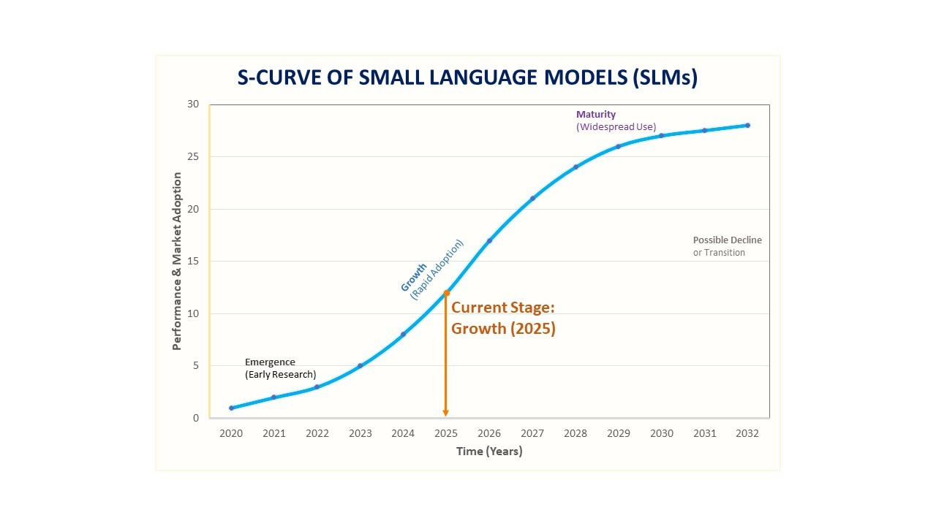
- Emergence (2020–2022): Early research and experimental use of smaller, efficient models began [1].
- Growth (2023–2025): Significant adoption, rising investments, and market momentum define this stage — where SLMs currently stand [2], [3].
- Maturity (2028–2030): Broader usage and slower innovation will likely characterize this period [6].
- Decline (after 2030s): Although not imminent, this stage may occur when new architectures or next-gen AI methods replace SLMs [5].
Currently, SLMs are positioned near the steep upward curve, reflecting strong technological progress and commercial growth [2] , [3].

Opportunities & Challenges:
Opportunities:
- Edge and On-Device AI:
SLMs allow AI functions to operate directly on low-power or offline devices, providing faster responses and better data privacy. This opens up possibilities for smart wearables, mobile assistants, and industrial IoT systems [1], [4].
- Cost and Energy Efficiency:
Due to their smaller size and reduced computational needs, SLMs are far more affordable to train and deploy. This makes AI adoption possible even for smaller companies and developing markets [3], [5].
Challenges:
- Limited Complexity Handling:
While SLMs are efficient, they may struggle with highly complex or context-heavy tasks compared to larger models. Finding the right balance between performance and efficiency remains an ongoing challenge [1], [6].
- Ethical and Regulatory Risks:
As SLMs become more common, organizations must manage concerns about bias, privacy, and security, ensuring compliance with AI regulations and data laws [2], [5].

Conclusion & Future Outlook:
Small Language Models are on a strong upward path and are expected to shape the next generation of AI development [2], [3].
Over the next five years, SLMs will likely become more specialized, modular, and easier to integrate into software systems [1]. Their energy efficiency, scalability, and affordability will help expand AI’s reach to more users and industries [4], [6].
Overall, SLMs represent a practical and sustainable direction for AI, balancing performance with real-world usability.

References:
[1] S. Kim et al., “A Comprehensive Survey of Small Language Models in the Era of Large Language Models: Techniques, Enhancements, Applications, Collaboration with LLMs, and Trustworthiness,” ACM Trans. Intell. Syst. Technol., vol. 16, no. 4, pp. 1–25, Apr. 2025. [Online]. Available: https://www.researchgate.net/publication/390671881_A_Comprehensive_Survey_of_Small_Language_Models_in_the_Era_of_Large_Language_Models_Techniques_Enhancements_Applications_Collaboration_with_LLMs_and_Trustworthiness

[2] F. Wang et al., “A Comprehensive Survey of Small Language Models in the Era of Large Language Models: Techniques, Enhancements, Applications, Collaboration with LLMs, and Trustworthiness,” ACM Trans. Intell. Syst. Technol., accepted 23 Aug. 2025. [Online]. Available: https://dl.acm.org/doi/10.1145/3768165

[3] GMI Insights, “Small Language Models Market Size, Share, and Forecast 2034,” Global Market Insights, 2025. [Online]. Available: https://www.gminsights.com/industry-analysis/small-language-models-market

[4] Harvard Business Review, “The Case for Using Small Language Models,” HBR Digital Articles, 2025. [Online]. Available: https://hbr.org/2025/09/the-case-for-using-small-language-models

[5] SoftwareMind, “Small Language Models and the Role They’ll Play in 2025,” SoftwareMind Insights, 2025. [Online]. Available: https://softwaremind.com/blog/small-language-models-and-the-role-theyll-play-in-2025

[6] Relecura, “Small Language Models: Their Growth, Significance, and Real-World Uses,” Relecura Reports, 2025. [Online]. Available: https://relecura.ai/small-language-models-their-growth-significance-and-real-world-uses

[7] ObjectBox, “The Rise of Small Language Models,” 2025. [Online]. Available: https://objectbox.io/the-rise-of-small-language-models

[8] Pieces.app, “Why Companies Are Turning to Small Language Models?,” 2025. [Online]. Availablehttps://pieces.app/blog/small-language-models-outshine-large-language-models-enterprise-users

